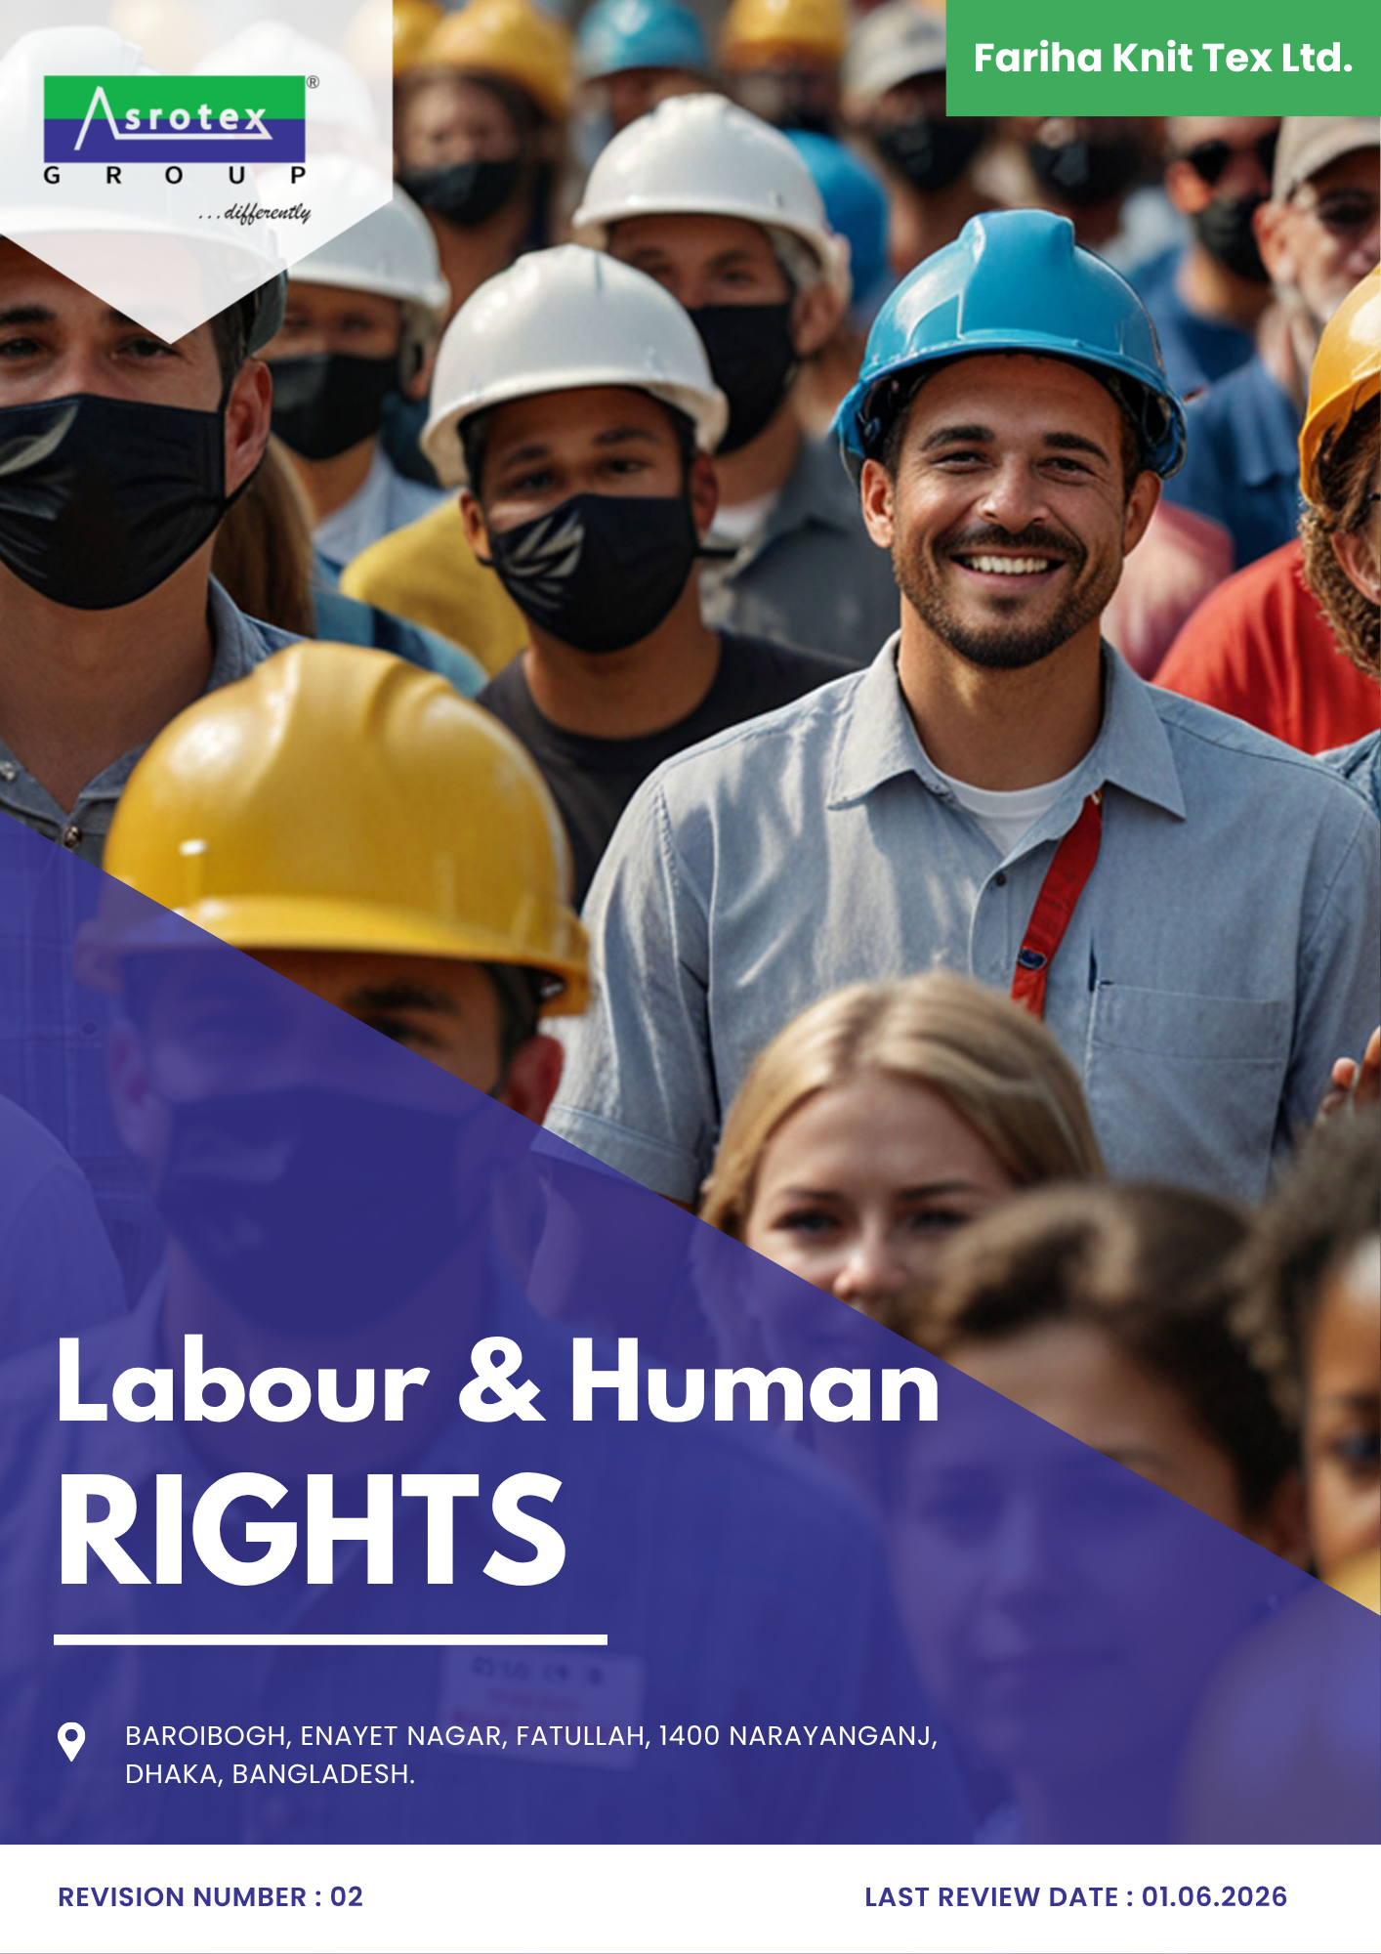
INDEX

PREFACE 3
SCOPE 3
POLICY DECLARATION 3
COMPLIANCE WITH LABOR AND HUMAN RIGHTS REGULATIONS 3
INITIATIVES AND TARGETS 4
ALIGNMENT WITH SDGS 7
MONITORING AND CONTINUOUS IMPROVEMENT 7
RESPONSIBILITIES 8
REVIEW MECHANISM 9
EMPLOYEE ACKNOWLEDGMENT FORM 10

PREFACE
Respecting labor and human rights is fundamental to creating a fair, safe, and empowering work environment. This policy outlines Fariha Knit Tex Ltd’s commitment to ethical practices, emphasizing health and safety, inclusivity, and employee development while ensuring compliance with international labor standards. It aims to build a workplace culture that values diversity, promotes social dialogue, and protects against any form of exploitation. By fostering accountability and aligning with the Sustainable Development Goals, this policy seeks to uphold human dignity across all levels of operations and within our broader network of stakeholders.

SCOPE

This Policy is applicable to following sites and all of its employees, workers, sub-contractors and other stakeholders:

Sr. No. | Site | Address
1 | Fariha Knit Tex Ltd. | Baroibogh, Enayet Nagar, Fatullah, 1400 Narayanganj,  Dhaka, Bangladesh.

POLICY DECLARATION
Fariha strives to uphold labor and human rights as a cornerstone of its operations, using 2022 as the baseline for measuring progress. We aim to foster a workplace built on fairness, safety, and inclusivity, ensuring every individual is treated with dignity and respect. Our approach emphasizes ethical practices, adherence to international standards, and proactive measures to support employee well-being and equitable opportunities. By embedding these principles into our operations, Fariha seeks to cultivate a culture of integrity and responsibility that aligns with global sustainability and social responsibility objectives.

COMPLIANCE WITH LABOR AND HUMAN RIGHTS REGULATIONS

Fariha Knit Tex Ltd. is committed to ensure that all aspects of our operations align with Bangladesh's labor laws and international human rights standards. We pledge to uphold the highest ethical standards in employment practices, employee welfare, and workplace safety.
Local Regulations: Fariha complies with all national labor and human rights laws, including:
- Bangladesh Labor Act (2006)
- Child Labor Elimination Policy (2010)
- Bangladesh Labor Rules (2015)
- Anti-Trafficking Laws
- Maternity Benefit (Bangladesh Labour Act, 2006, as amended) and related welfare provisions
- Minimum Wage Board Gazette Notifications (sector-specific minimum wage orders)
International Standards: We adhere to global frameworks, including:
- Universal Declaration of Human Rights
- International Labour Organization (ILO) Conventions
We are dedicated to ongoing monitoring and improvement to exceed compliance requirements and foster a culture of fairness and dignity in our operations.

INITIATIVES AND TARGETS

- Employees' Safety and well-being
- To create a safe and supportive work environment where all employees feel protected and their health and well-being are prioritized
- To conduct comprehensive health monitoring and safety programs to ensure employees can perform their duties without undue risk.
- To reduce workplace accidents by 25% till 2030 and to ensure 100% of employees receive safety training annually. Additionally, quarterly compliance checks will be conducted for all safety equipment.

- Employee Engagement
- To foster a culture of open and constructive communication by encouraging collaboration between employees and management.
- To actively promote channels for feedback, collective bargaining, and resolution of workplace concerns.
- Organize quarterly meetings to enhance collaboration between management and labor representatives, aiming to achieve 85% participation by 2030.

- Child Labor, Forced Labor, and Human Trafficking
- To maintain a zero-tolerance policy toward child labor, forced labor, and human trafficking and integrating ethical practices into all operations and extending it to our supply chain also.
- Introduce a supplier recognition program to reward compliance and excellence in ethical labor practices.
- Conduct audits of 100% of tier-one suppliers for compliance by 2030, and provide anti-exploitation training to all suppliers.
- To maintain zero confirmed cases of child labour, forced labour or human trafficking across 100% of operations by 2030.

- Workplace Conditions
- To maintain fair and equitable working conditions by providing decent wages, adequate facilities, and a balanced workload for all employees. Compliance with international labor standards remains a key focus.
- To continuously organize annual employee satisfaction surveys on working conditions with a target of achieving an 85% positive satisfaction rate by 2030.

- Diversity, Equity, and Inclusion (DEI)
- To foster an inclusive workplace where all individuals are valued, respected, and provided equal opportunities. Diversity is actively promoted at all levels of the organization, including in decision-making processes.
- To increase women’s representation in leadership roles to 30% by 2030 and align workforce diversity ratios with national benchmarks by 2030.

- External Stakeholder Human Rights
- To partner with leading advocacy organizations to promote human rights across the value chain. This includes collaborating on awareness programs, ensuring ethical practices, and supporting capacity-building initiatives. Together, we will strengthen human rights protections and drive positive change in our supply chain.
- To integrate human rights clauses into all supplier contracts and ensure 100% compliance by 2030.
- To conduct human rights impact assessments for all major projects by 2030 and address 100% of stakeholder grievances within 45 days.

- Career Development and Training
- To foster a workforce that thrives on learning and development by supporting employees in pursuing career advancement through skills development and training opportunities.
- Each employee will receive a 15 hours of training annually, with internal promotions increasing by 10% by 2030.
- Collaborate with 3 educational institutions to offer employees access to advanced certification courses and degree programs by 2030.

- Grievance Mechanism and Anti-Retaliation
- To provide accessible, confidential, and impartial grievance channels, including a dedicated hotline/suggestion-box system, enabling employees and workers to raise concerns without fear of retaliation.
- Resolve 100% of reported grievances within 30 days and achieve zero substantiated cases of retaliation against complainants, monitored annually through 2030.

- Discrimination and Harassment
- To maintain a workplace free from discrimination, harassment, bullying, intimidation, and retaliation.
- To provide discrimination and harassment prevention training to 100% of employees annually and thereafter.
- To maintain a formally established and active Anti-Harassment Committee across 100% of the facility by year 2030.
- To provide specialized discrimination and harassment prevention, complaint handling, and investigation training to 100% of Anti-Harassment Committee members by 2030.

ALIGNMENT WITH SDGS

MONITORING AND CONTINUOUS IMPROVEMENT

To ensure the ongoing effectiveness of labor and human rights policies, regular monitoring will be conducted across all levels of the organization. Key performance indicators (KPIs) will be tracked to assess compliance, identify areas for improvement, and measure progress towards goals. Employee feedback, audits, and incident reporting systems will be utilized to provide insights for necessary adjustments. Continuous improvement initiatives will be driven by data analysis, corrective actions, and best practice sharing. This process will be reviewed periodically to incorporate new standards, regulations, and feedback, ensuring the policy remains dynamic and relevant to evolving needs.

RESPONSIBILITIES
- Senior Management: Ensure integration of labor and human rights policies into the company’s strategy, allocate necessary resources, and set the tone for organizational commitment to these values.
- HR Department: Develop and implement training programs, manage grievance mechanisms, and track compliance across all departments.
- Compliance Team: Regularly assess regulatory adherence, perform audits, and recommend corrective actions for any compliance gaps.
- Managers/Supervisors: Act as policy ambassadors, handle day-to-day employee concerns, and ensure adherence to labor standards within teams.
- Employees: Comply with policies, raise concerns, participate in training, and engage in constructive feedback.
- Suppliers/Partners: Ensure ethical practices align with company standards, undergo periodic evaluations, and improve operations in line with the policy.

REVIEW MECHANISM

The HR Manager will conduct an annual policy review to ensure legal compliance and goal alignment. Quarterly monitoring and annual audits track key performance indicators, while feedback is gathered through surveys and grievance systems. Incidents are logged and resolved promptly.

REV. No. 02

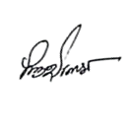
LAST REVIEW DATE: 01.06.2026 NEXT REVIEW DATE: 01.06.2027

APPROVED BY: M Shohidul Islam

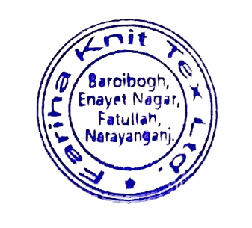
REVISION HISTORY
Rev. No. | Review/Effective Date | Description of Changes | Approved By
00 | 01.06.2024 | Initial Issue
01 | 01.06.2025 | Annual policy review and update.
02 | 01.06.2026 | Initiatives and Targets topic

EMPLOYEE ACKNOWLEDGMENT FORM

I hereby confirm that I have received, reviewed, and understood the Labor and Human Rights Policy of Fariha Knit Tex Ltd.. I recognize the company’s dedication to fostering a workplace that prioritizes fairness, dignity, safety, and inclusivity while adhering to ethical practices and international labor standards.
I understand my role in upholding these principles and agree to actively contribute to a respectful and equitable work environment. I also acknowledge that compliance with this policy is a shared responsibility and an integral part of my duties as an employee.
By signing this acknowledgment, I affirm my commitment to supporting the organization’s efforts to protect labor and human rights and to report any violations or concerns in accordance with the procedures outlined in the policy.
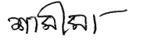
Name: Shamima Khatun
Position: Junior FQI
Signature: 04-06-2026
Date: __________________________

